Technical report of project Bio & Health

## Andreas Nalmpantis – 3699, Ioannis Oikonomidis – 3668,

## Chris Papakonstantinou – 2499, Iordanis Kokkinidis – 3412

## 1 April 2022

# Introduction

This is the second part of our 3-part project. In this stage we completed the front-end side of our website. The technologies that were used were HTML, CSS, JavaScript and Bootstrap to help us make the website responsive. In this report, a quick description of each page of our website will be given, describing each page’s main functions, our thought process and what remains to be done in the third part, in which we will develop the back-end for our site.

# Front End

## Navbar

The header is included in every file of our website. It provides some quick navigation shortcuts to the user and some links to pages related to the user’s account.

First, it contains a “burger” menu which, when clicked, reveals a list of links for every product category in our store. When the user clicks one of these links, he will be transferred to a different page which will display all the products of the selected category.

Then we have the Bio&Health logo. It is a link which acts as a home page button.

After that, there is a search bar. The user can type in the product he is looking for, or keywords related to what he is looking for, and he will be transferred to a different page with the results, depending on what he typed.

In the end, there are 3 icons, the “account” icon, the “cart” icon, and the “favorites” icon. The account icon contains a dropdown menu, with links that provide the way for the user to sign in or create a new account, or (if he is already signed in) to edit his account information and log out. The cart icon opens the cartpage.html file, which displays the products that the user has added to his cart and the favorite icon opens the favorites.html file which displays the products that the user has added to his favorites.

To create the header, we used plain CSS and Bootstrap for the layout and some utilities.



## Footer

It is also included in every page and is located at the bottom of it. It contains some general information about the store and several ways of contact.

The first section under the “Contact” heading has some contact information along with the link “contact form” which takes the user to the contactForm.html page in which he can write a message to the administrator.

The second section contains some location information for our store and the last section contains links for our social media accounts. The icons both in the header and the footer are taken from [font awesome](https://fontawesome.com/) and so are all the other icons used in any page.

To structure the footer and make it responsive, we used the Bootstrap grid layout (classes row and col)



## Index.html

The home page of our website. It contains various links and media content for the user.

At the top of the page there is a slideshow, which will contain some representative content for different parts of our website and will link to them, giving those parts more visibility and providing easier navigation for the user. The content will be filled during the third stage of the project, when all the products will be added.

In the middle we have a section which displays all the product categories that we have in our store. Both the images and the text are links which will take the user to the search page, displaying all the products of the selected category.

Lastly, we have some more representative content for different things, such as new products, offers, and some useful information regarding our store.

For the layout of the page, we used the Bootstrap grid and flexbox. For the slideshow, we used the Bootstrap class “carousel” along with all of its subclasses. For styling, in this page and all of the pages, we used plain CSS and Bootstrap utilities.

The current images are just placeholders and will get replaced later on.

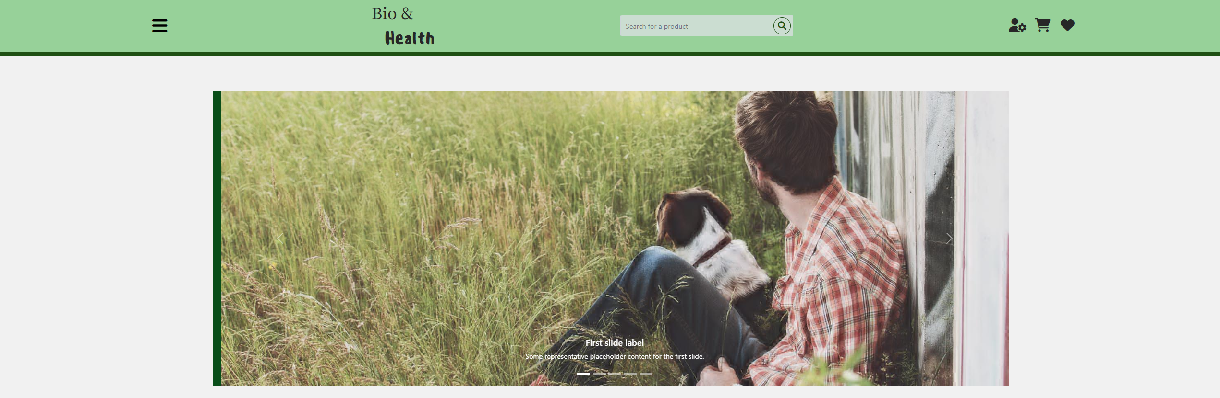

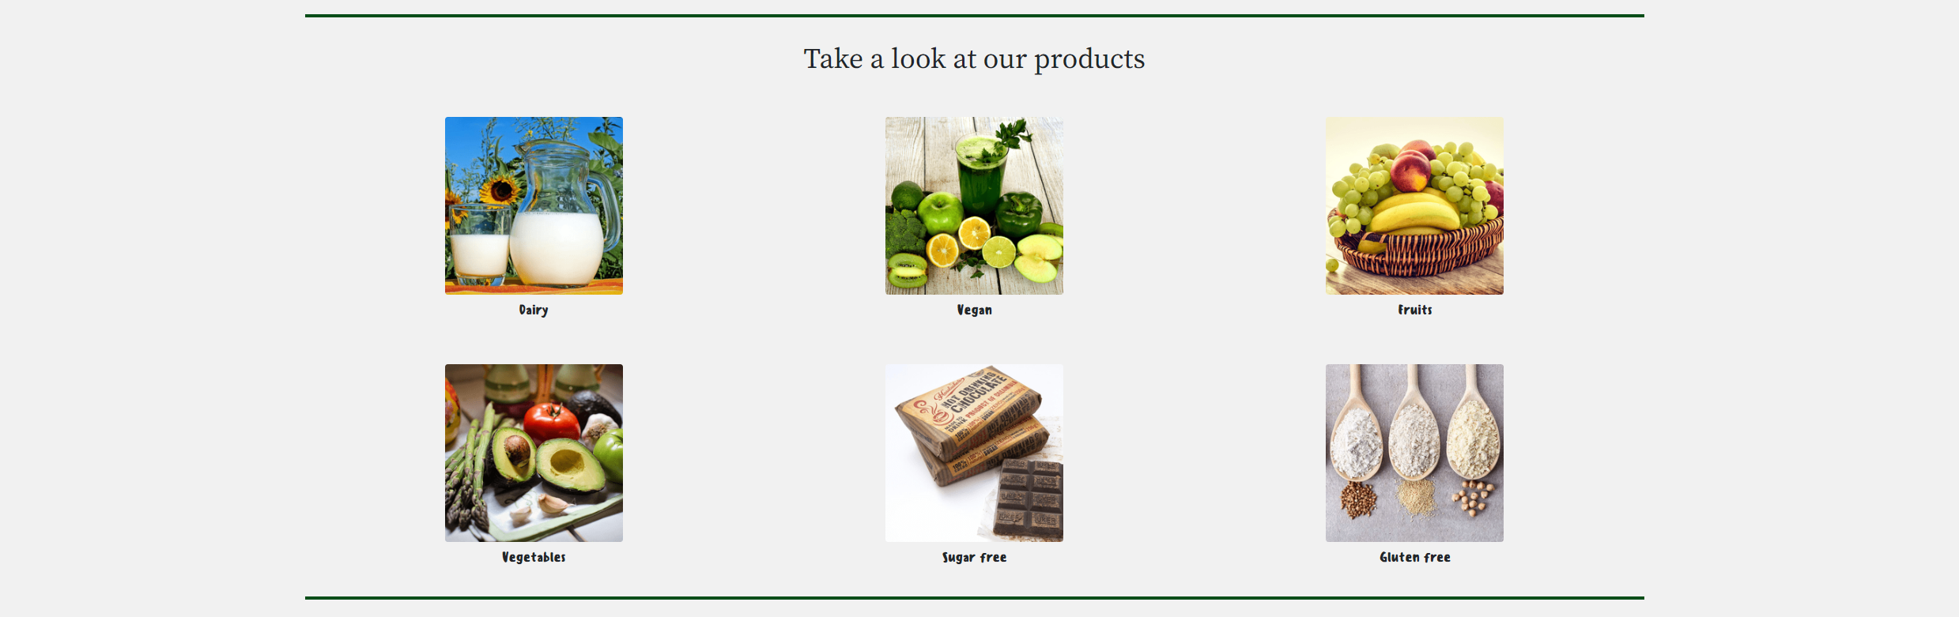

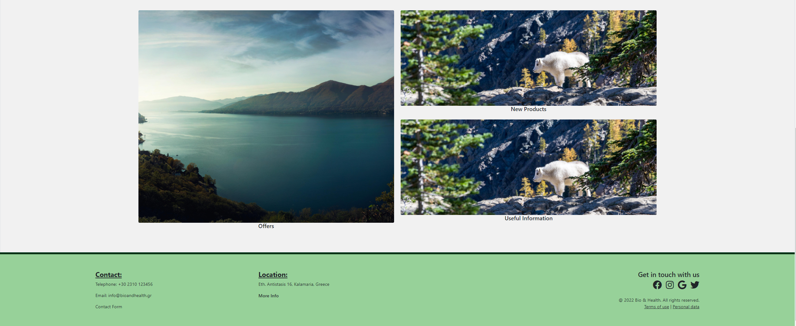

## AdminCart.html

This page shows the admins the information of an order that a customer made. It shows all of the information the customer inputted when making the order using the UserCheckoutPage.html as well as all of the items that the user’s cart was held when the order was made including their amounts, their total prices and the user’s shipping choice.

The admins can go back to the page that shows all of the pending orders by clicking the “Back to orders” button located on the right side of the page.

This page was build using bootstrap 5 and mainly rows and columns.

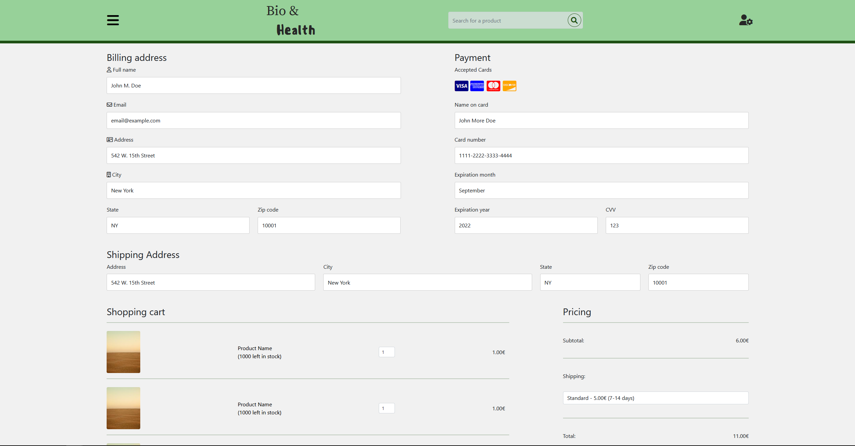

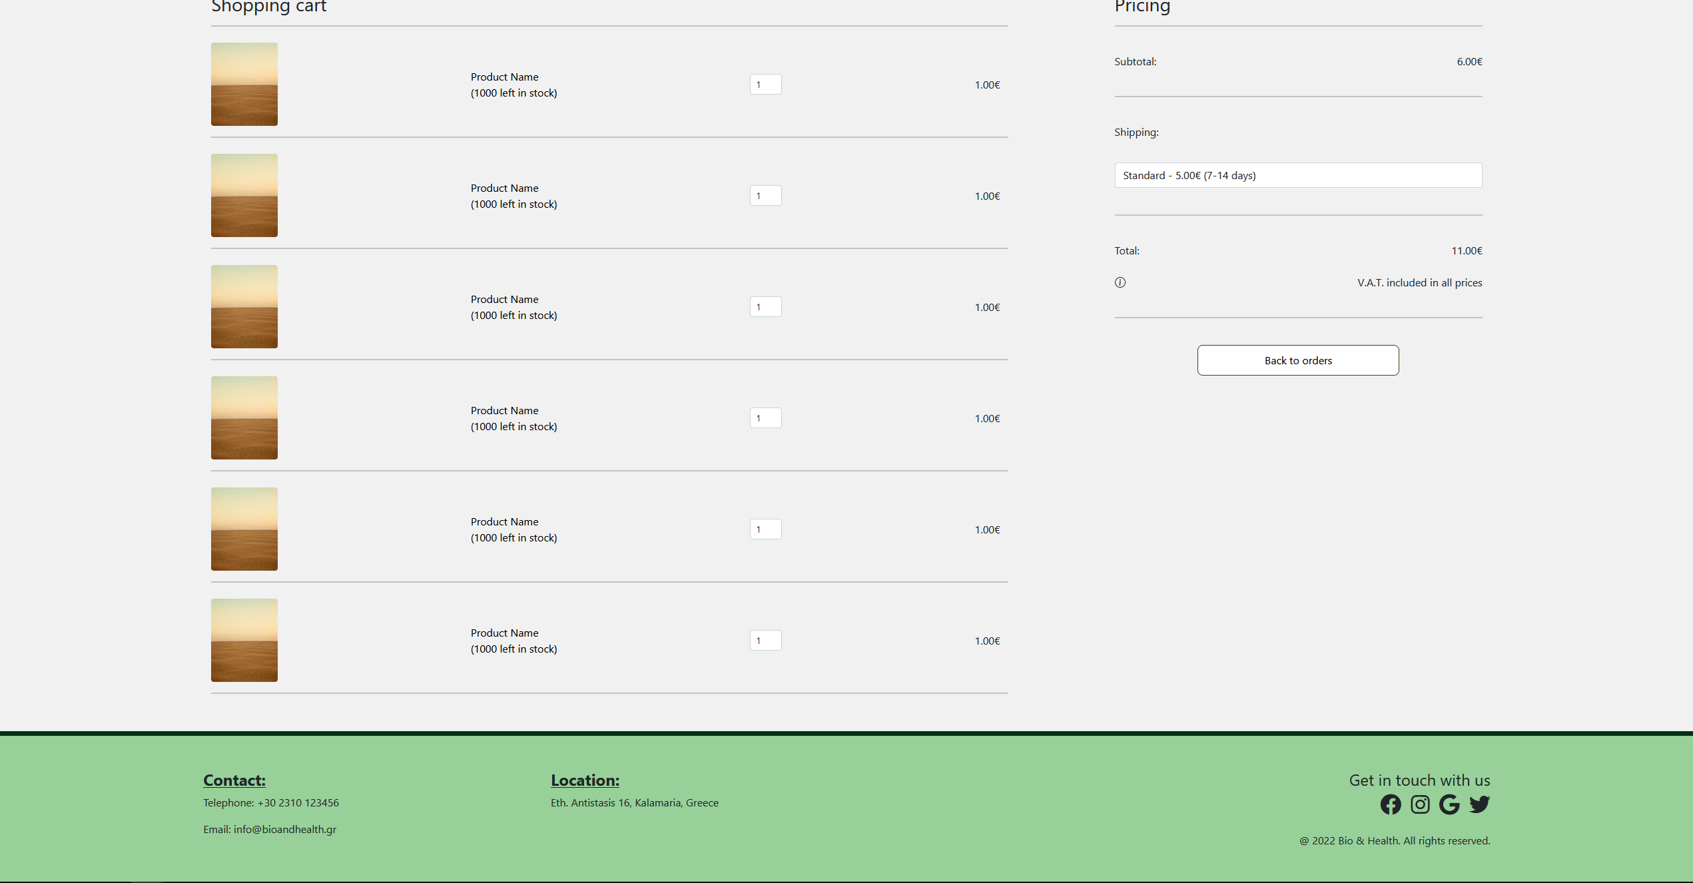

## AdminEditProduct.html

Page in which the admis can edit the information of a product, in case something has changed, or they made a mistake.

Both the new product and edit product are structured using Bootstrap grid and flexbox.

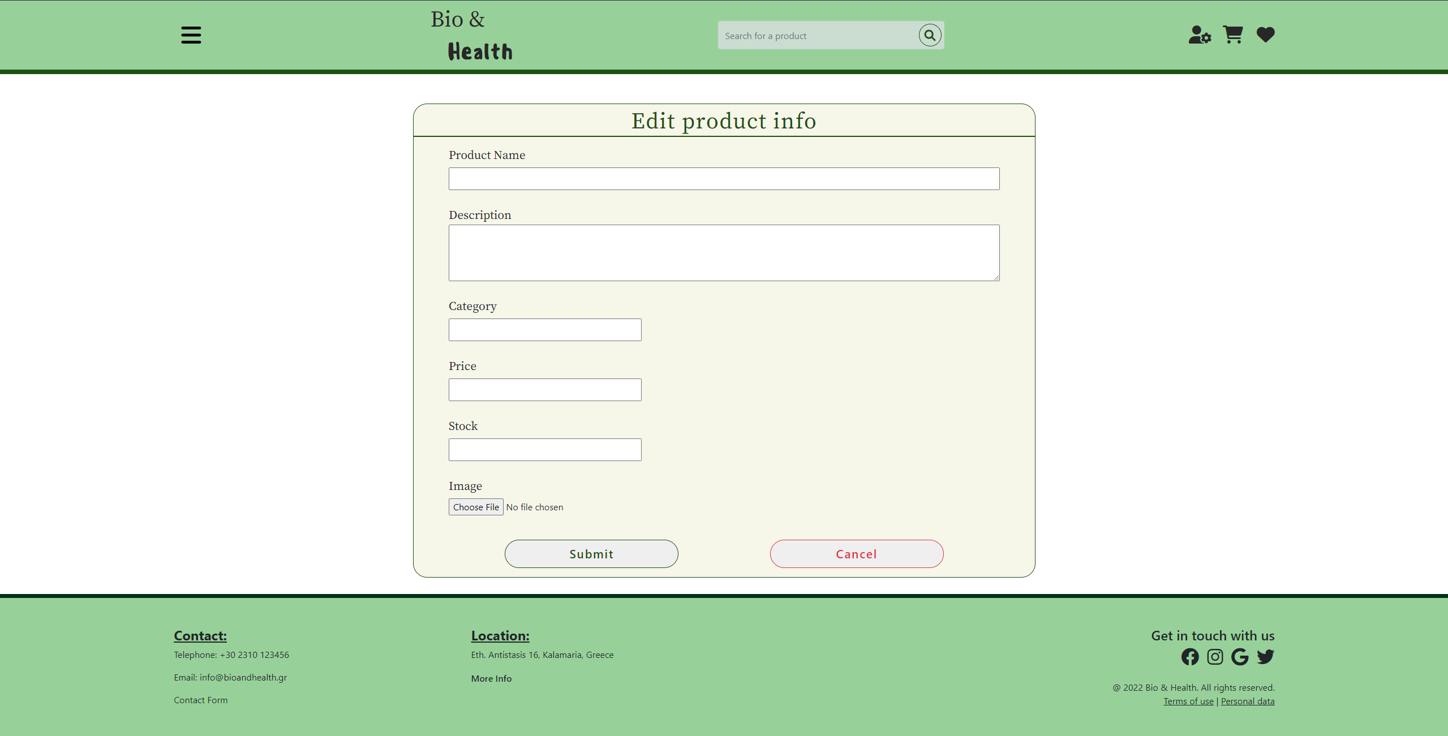

## AdminIndex.html

This page is similar to the home page Index.html with the difference that it is the home page the admins see when logged in as admins and it has different options on the navbar “hamburger” menu which allow them to perform administrative actions.

The page is built using the exact same layouts as the Index.html page.

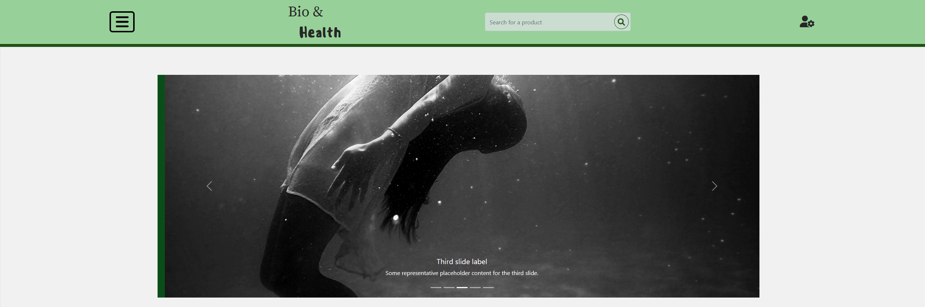

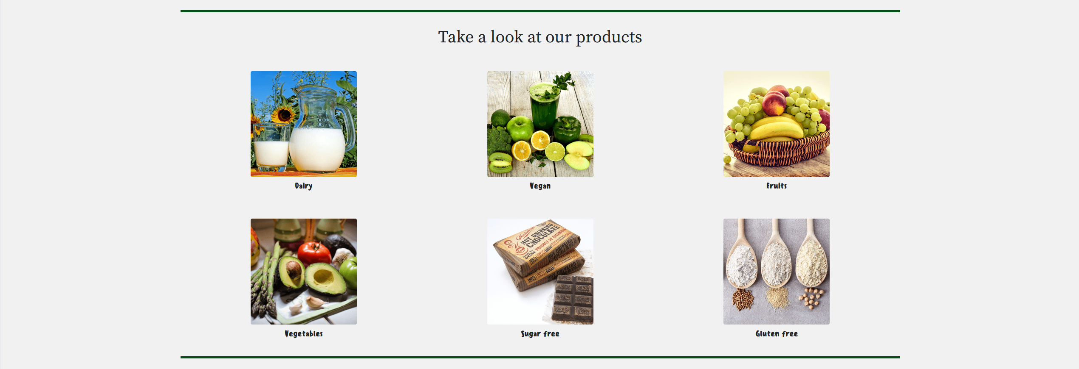

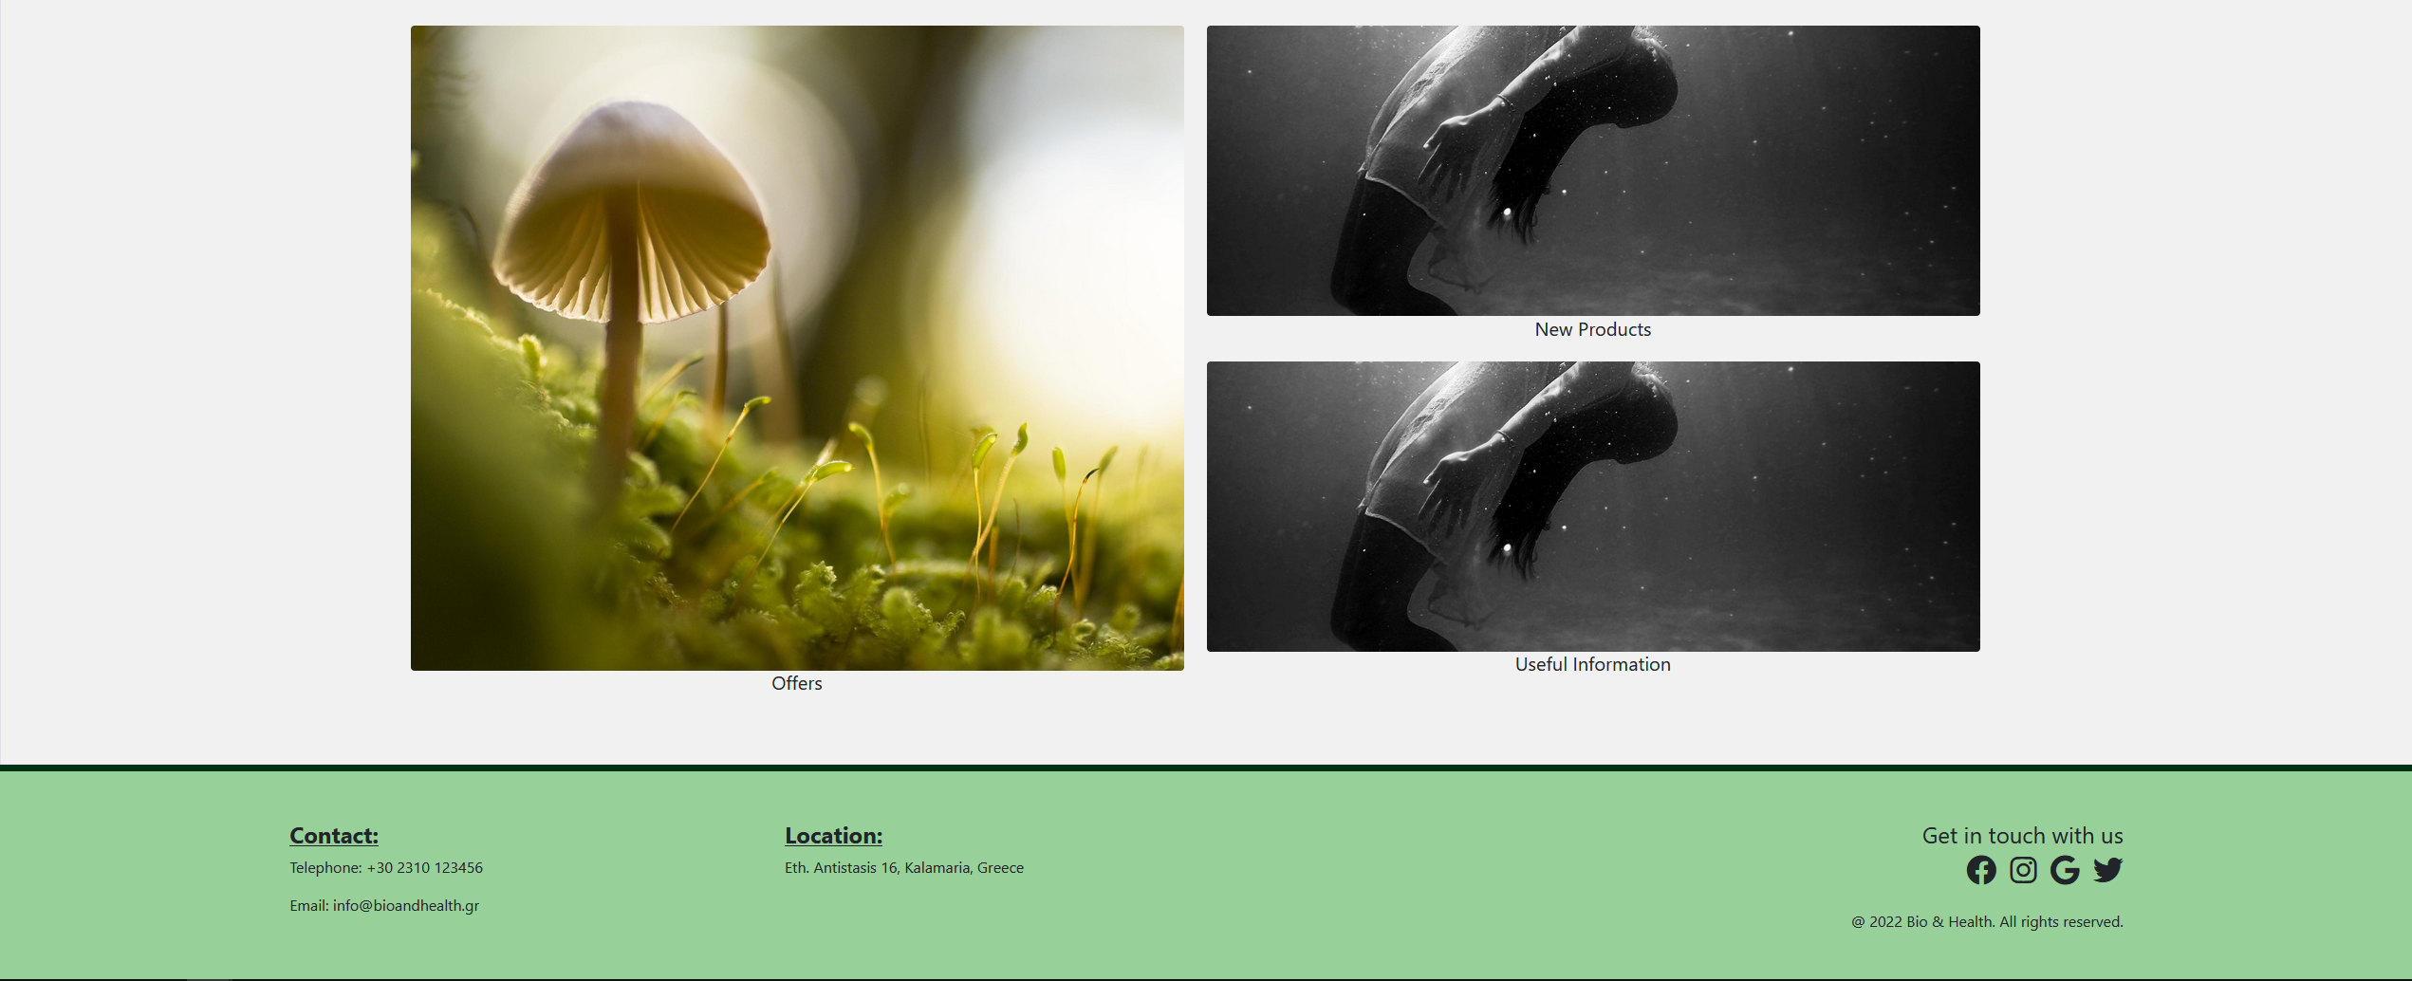

## AdminNewProduct.html

In this page, the admins will be able to add a new product for the store by typing the required information in the form and submitting it. The page also contains a list of the product categories available and an option to add a new category.

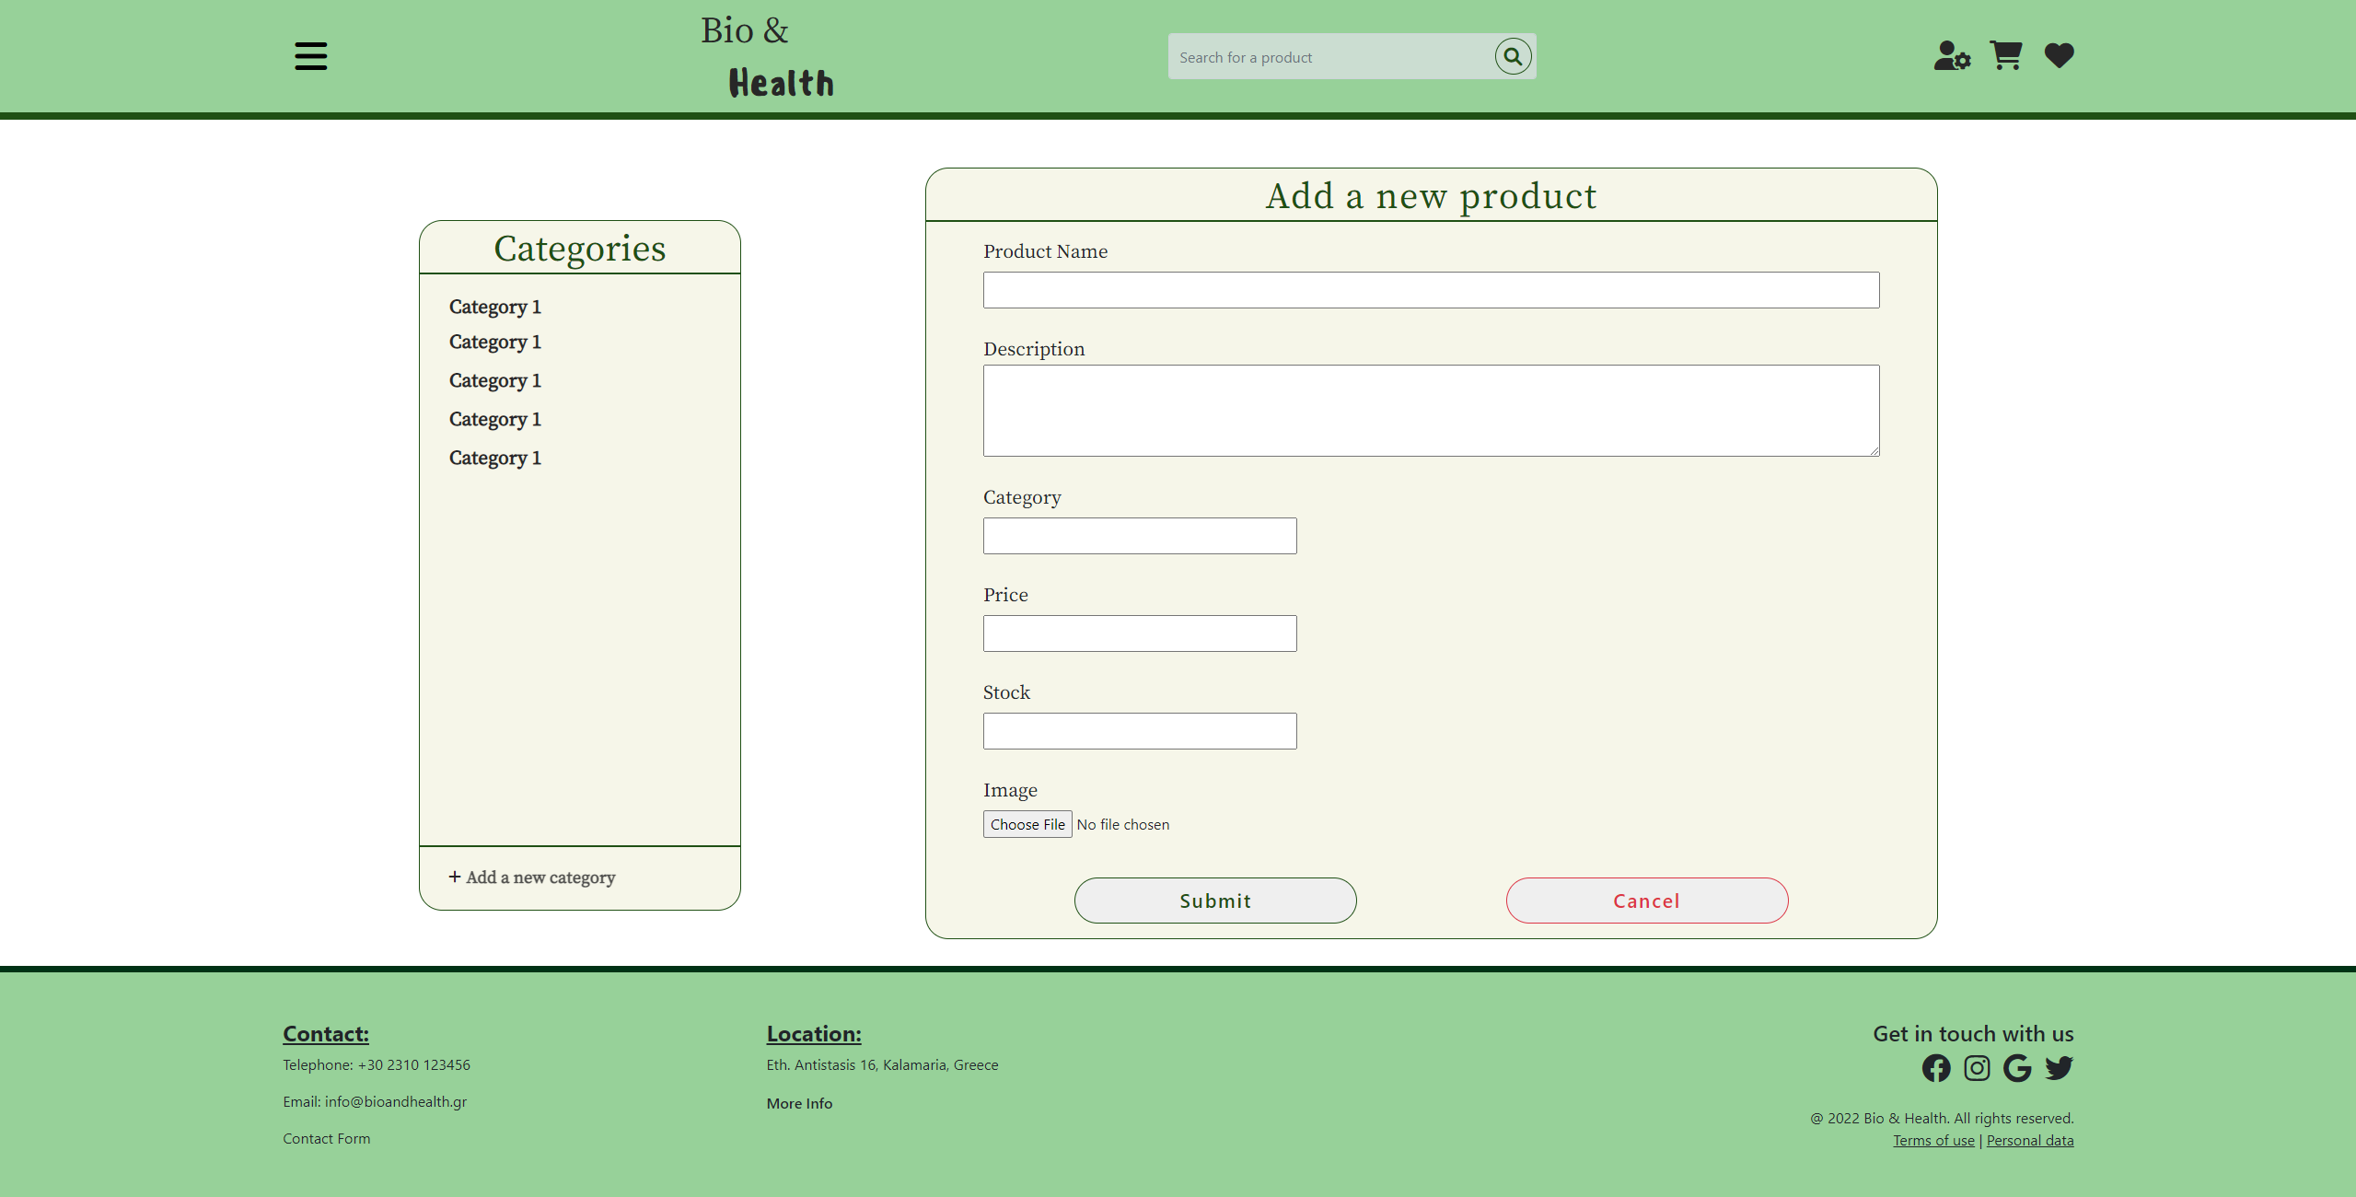

## AdminPendingOrders.html

In this page the admins can see the pending orders submitted by the users. The available info about the orders on this page is the order ID, the username of the user who made the order, the submission date of the order, the date it has to have been delivered by and its total cost.

By pressing the “Details” button of one of the orders, the admin be redirected to the page AdminCart.html which shows all the information of the specific order. Additionally, by pressing the “Complete” button for one of the orders, that order is marked as complete and is removed from the list of pending orders. For now this button only sets the corresponding row’s inner html to empty but once the back-end is complete, it will remove the said order from the list of pending orders.

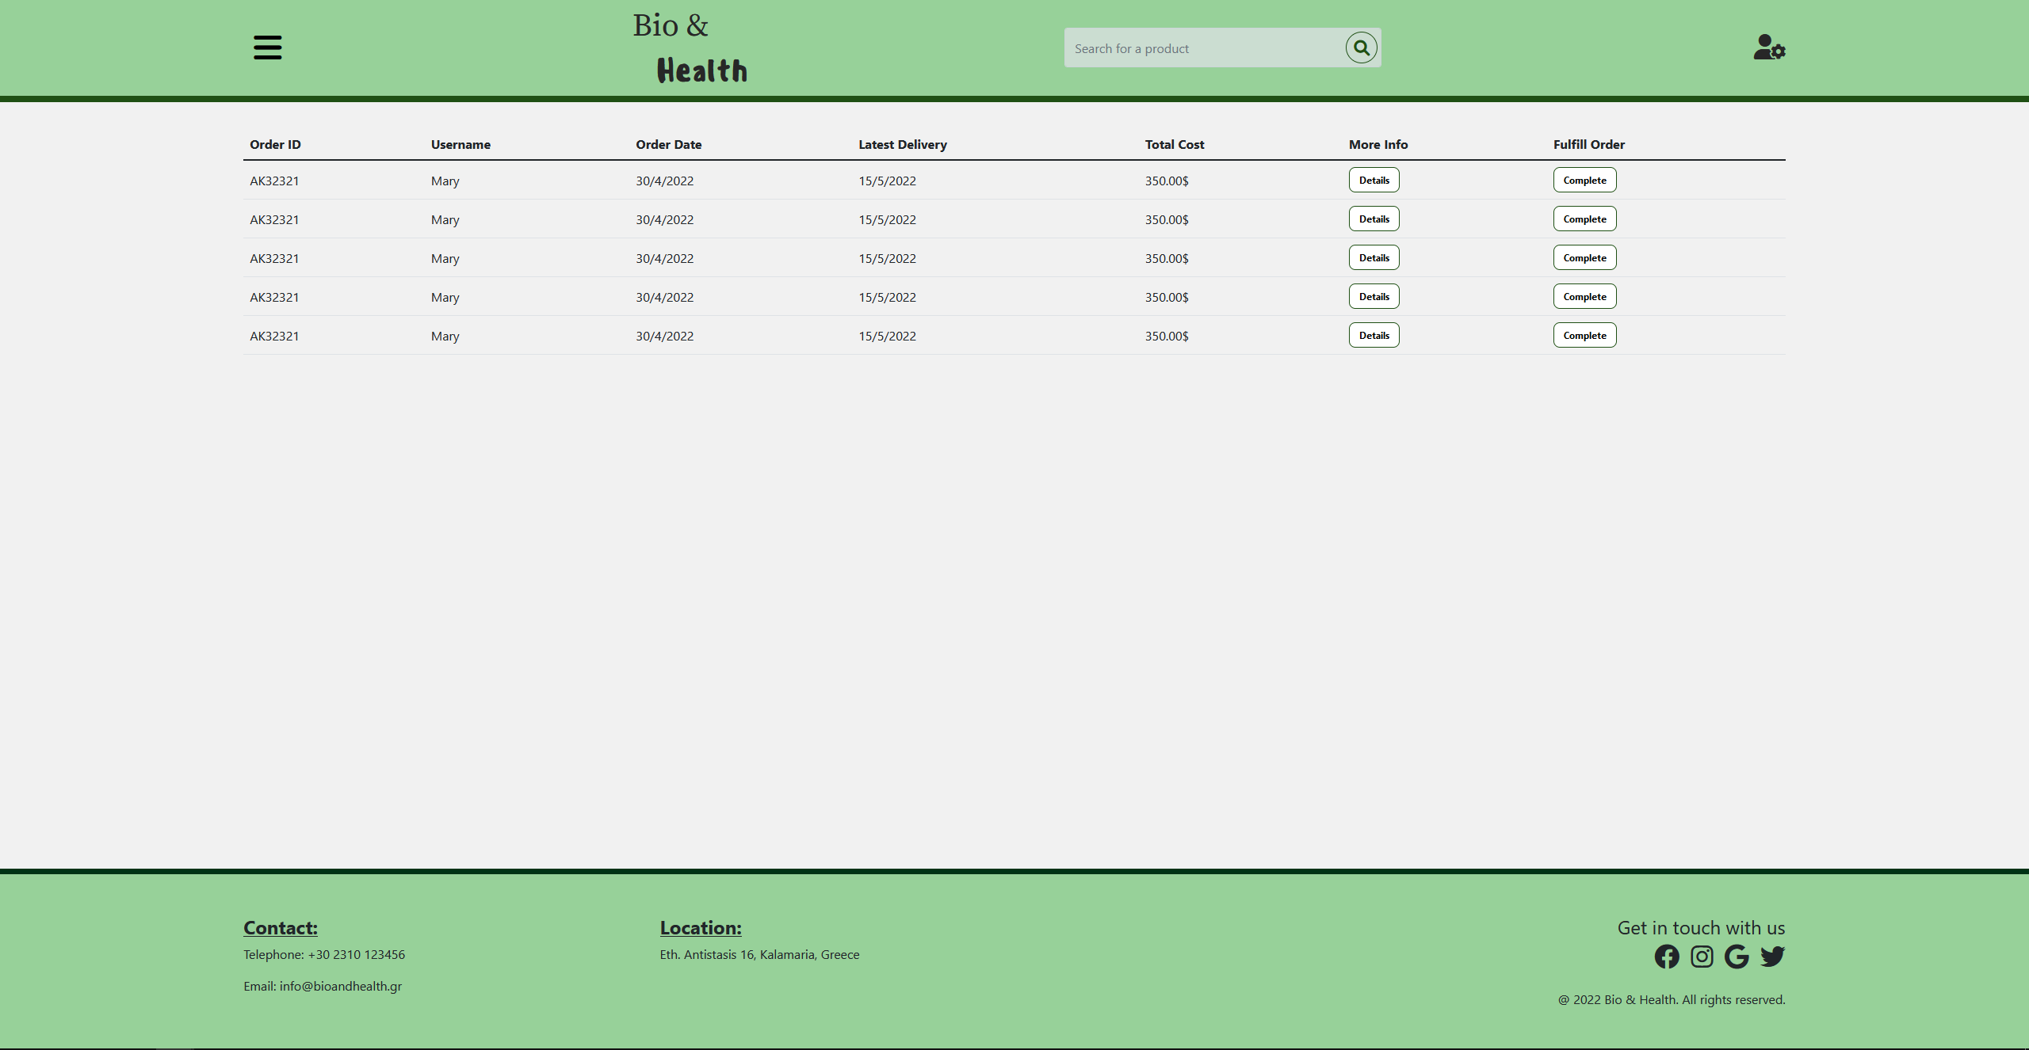

## AdminSearch.html

Using this page, the admins can search for and select products to edit or delete from the database. More specifically, the products showed can be filtered to show all products or only products that belong to a specific category using the “Show only:” dropdown menu. The products can also be sorted based on specific characteristics they have using the “Sort by:” dropdown menu.

The two menus mentioned above have no effect as of right now, but once the back-end is complete, they will be fully functional. As we can see in the figure that follows, for every product the admins can see their name, amount in stock, cost and the categories the product belongs to (the categories are represented by the colored “i” icons which will likely change to more fitting icons in the third part).

The image shown for each product are randomly selected placeholders until we have a working back-end which will provide each product image, name, etc. There are also two buttons per product, the “Edit” button which redirects to the AdminEditProduct.html page which allows the admins to edit the specific product’s info (this redirect also happens by clicking on the product’s image) and the “Delete” button which upon being clicked opens a modal pop up asking the admin if they are sure they want to delete the product from the database.

This pop up has a “Delete” button which permanently deletes the product from the database and a “Cancel” button which cancels the deletion.

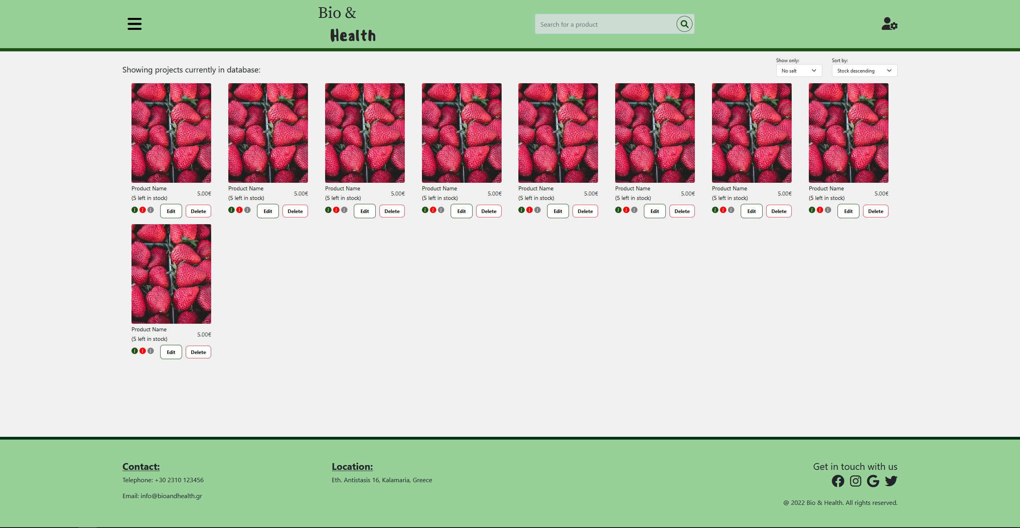

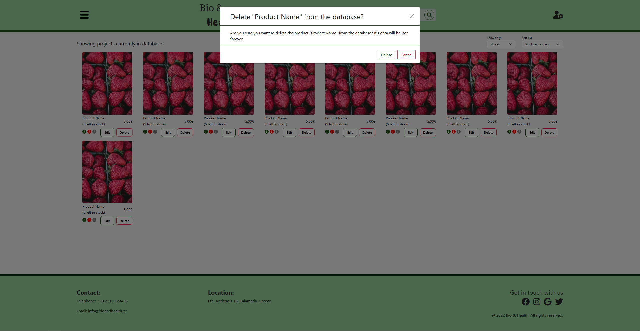

## AdminSignIn.html

This page is where the admins sign in. They type their credentials in the given form and submit it. They can also sign in as customers by clicking the “Sign in as Customer” button which redirects to the corresponding page and they can go to the user sign-up page by clicking the “Sign Up” button.

For the layout we used the Bootstrap grid, and flexbox.

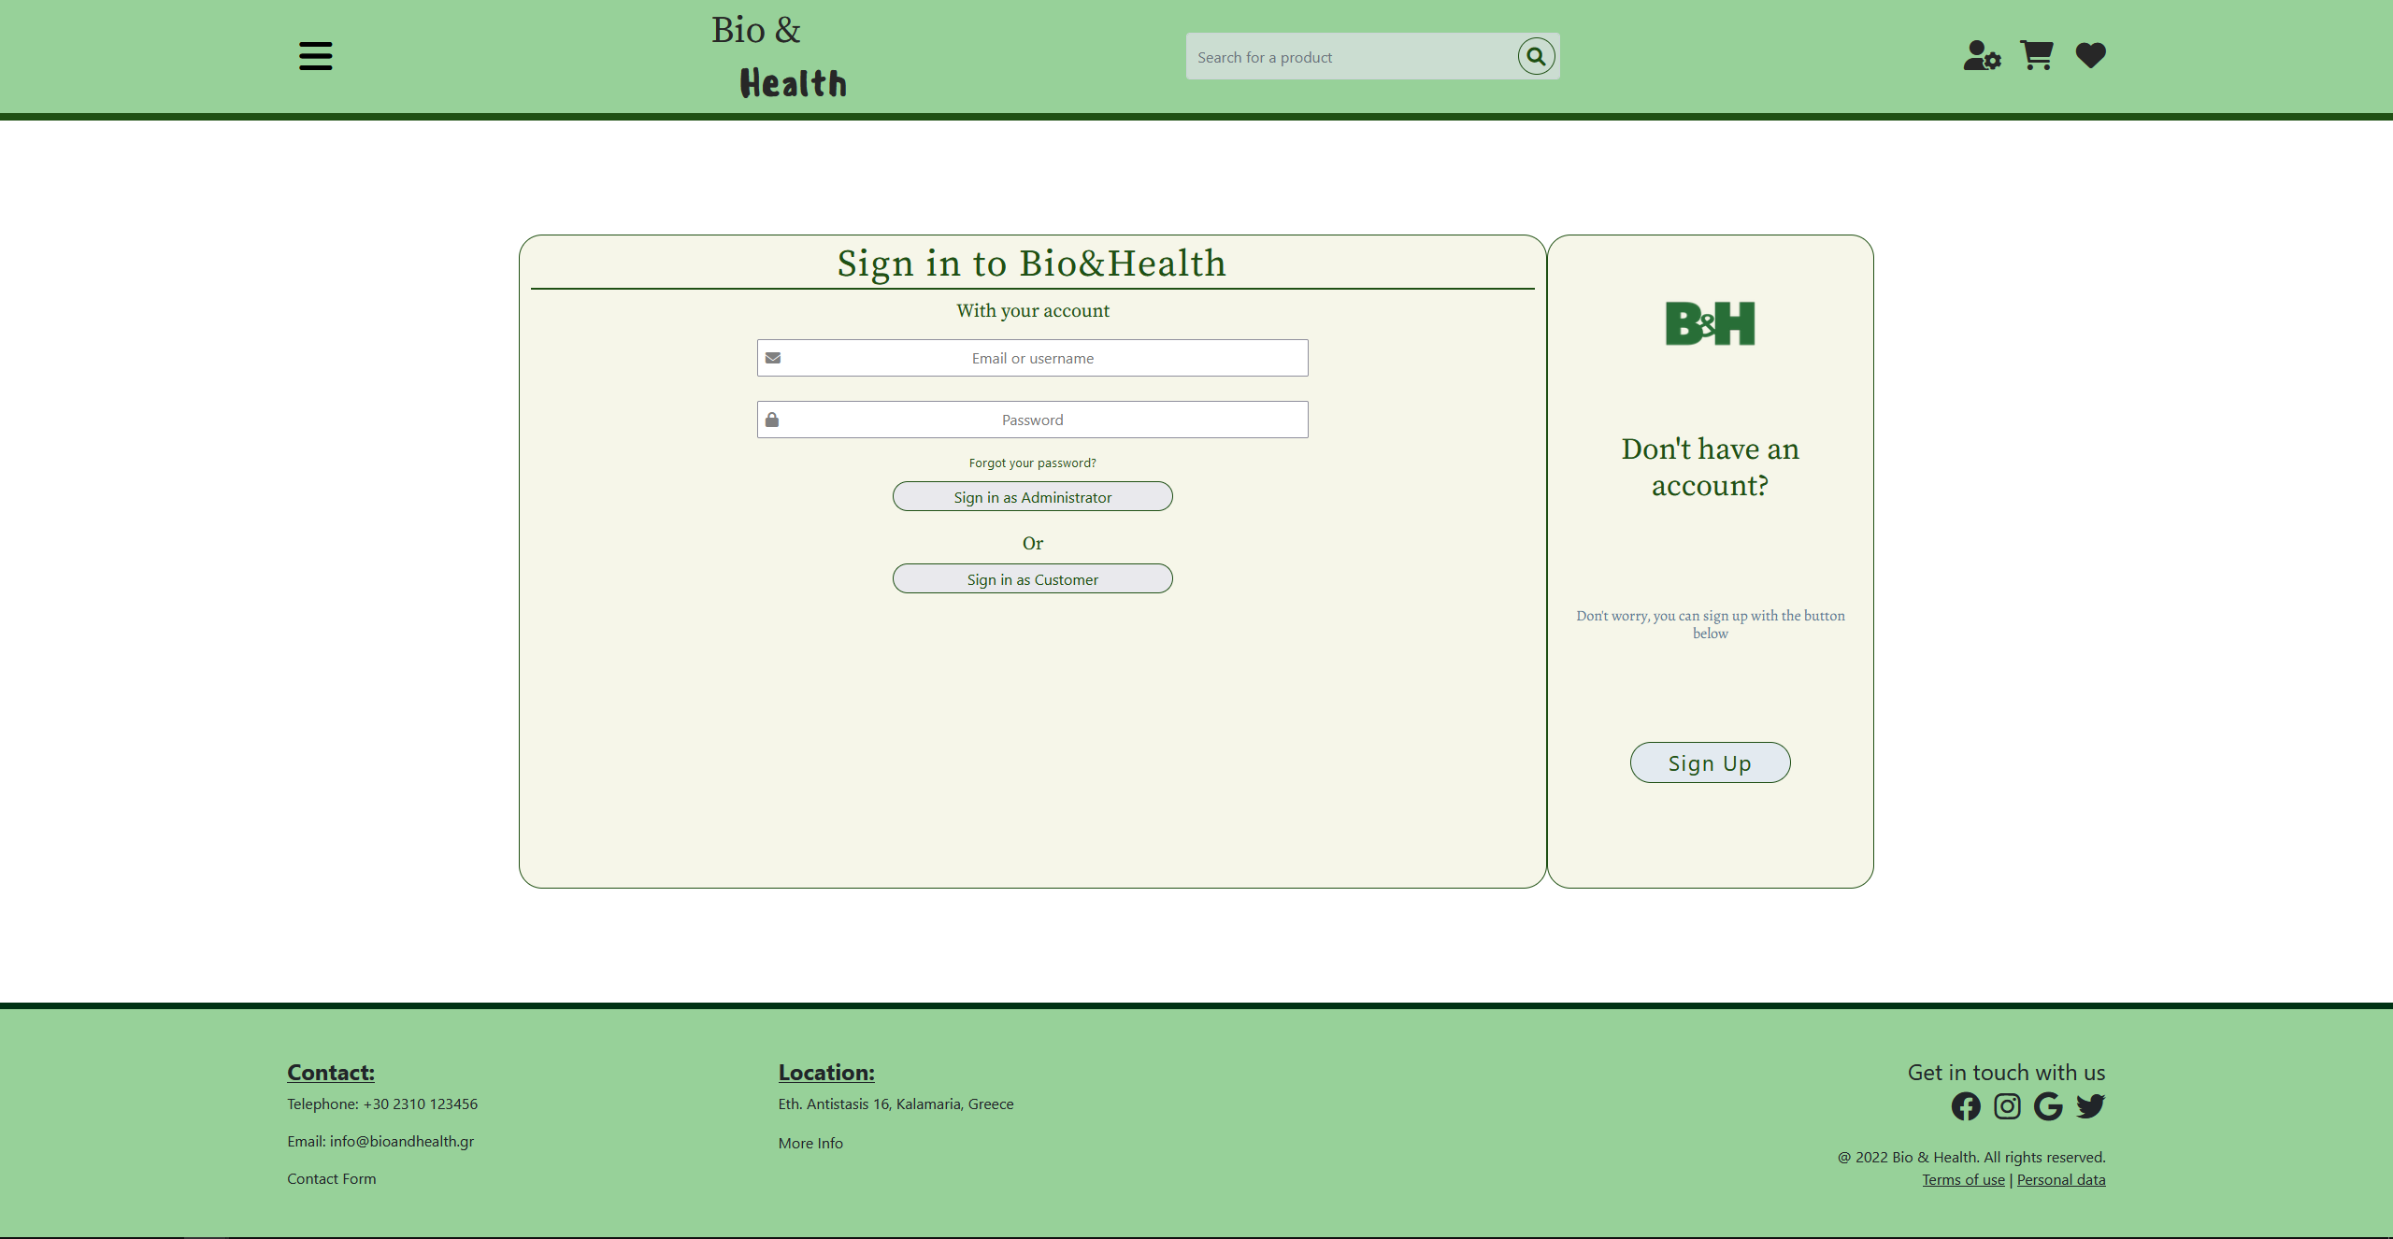

## UserAccountInfo.html

In this page, the users can edit their account information. The input fields, when the back-end is complete, will display the information given by the user and they will then be able to change it by editing the fields and submitting the form.

The layout used for this page has mainly been flexbox.

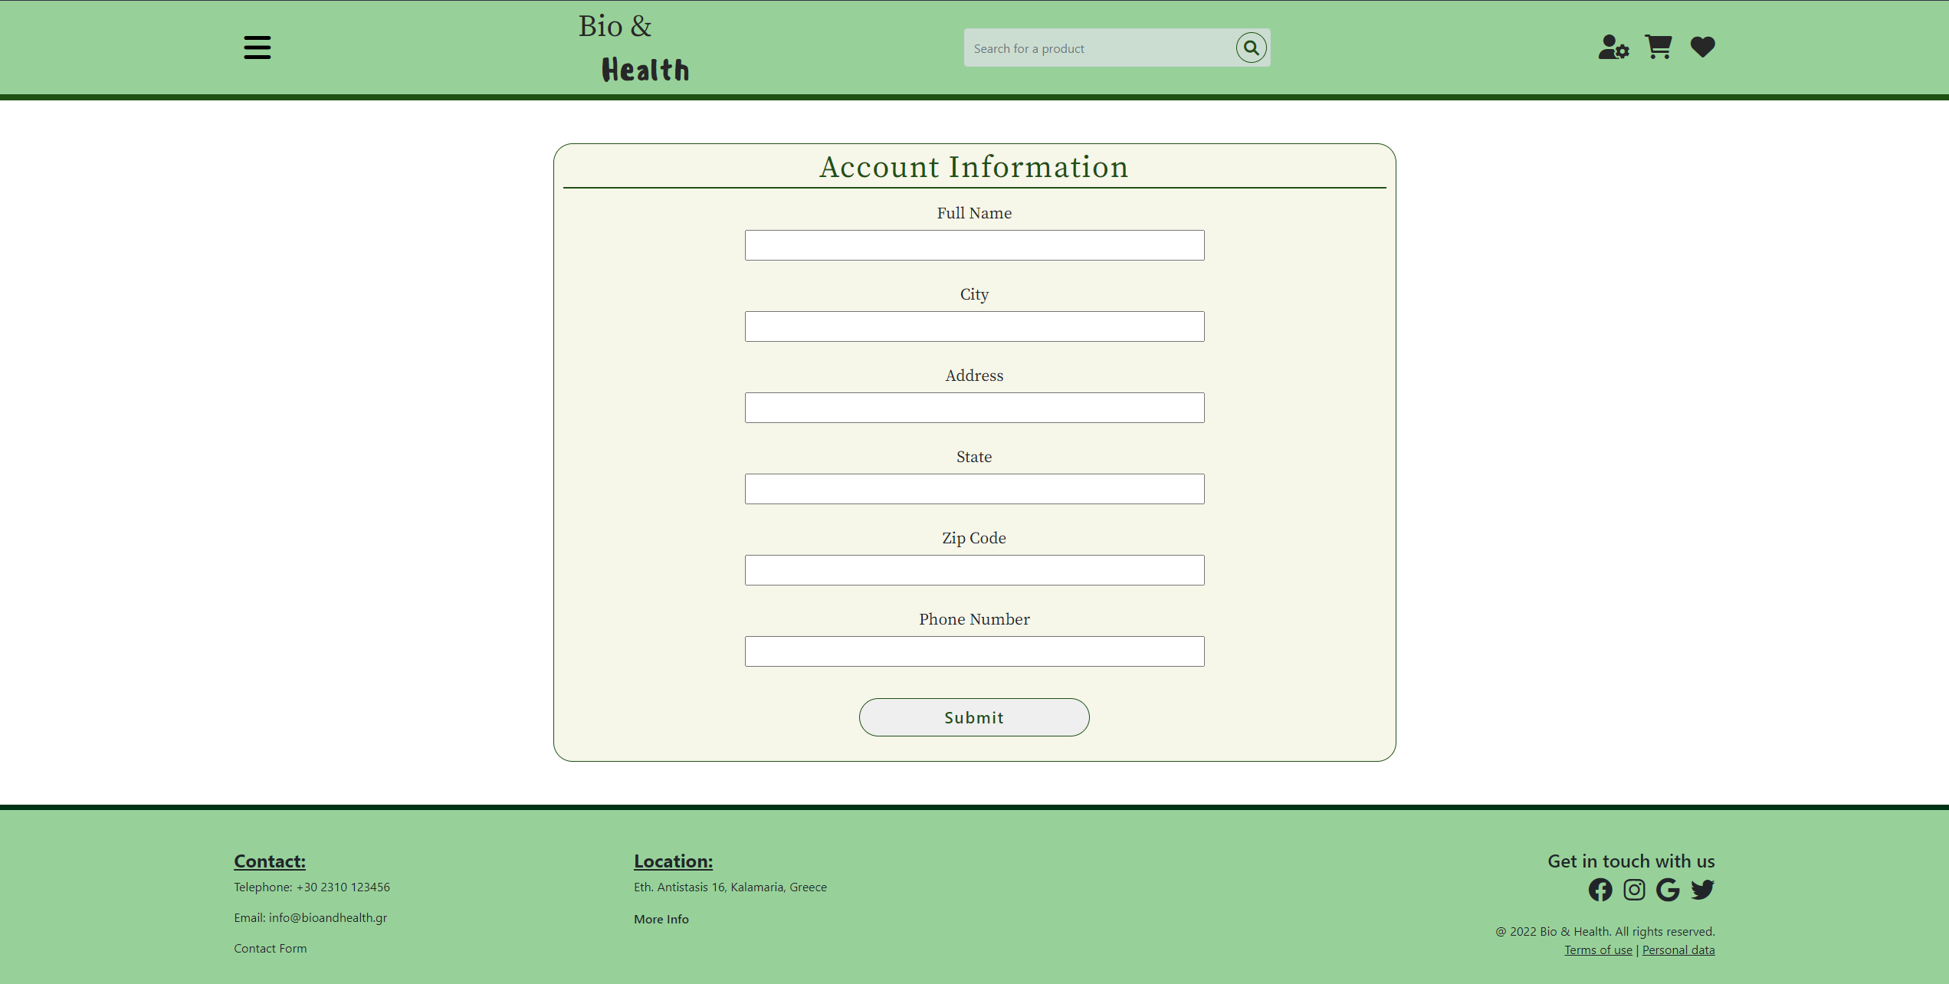

## UserCartPage.html

## UserCheckoutPage.html

## UserContactForm.html

## UserContactFormCompletion.html

## UserFavorites.html

The favorites page contains a table of the favorite products of the user, together with information about these products. For each one of the favorite products, the page shows the product’s name and its price. The layout of the page is created by using the table tag of HTML5 and tr and td tags to declare the rows and the content of all the cells of the table. Users can visit the favorites page when they click on the small heart shown on the right side of the navbar shown on all user pages.

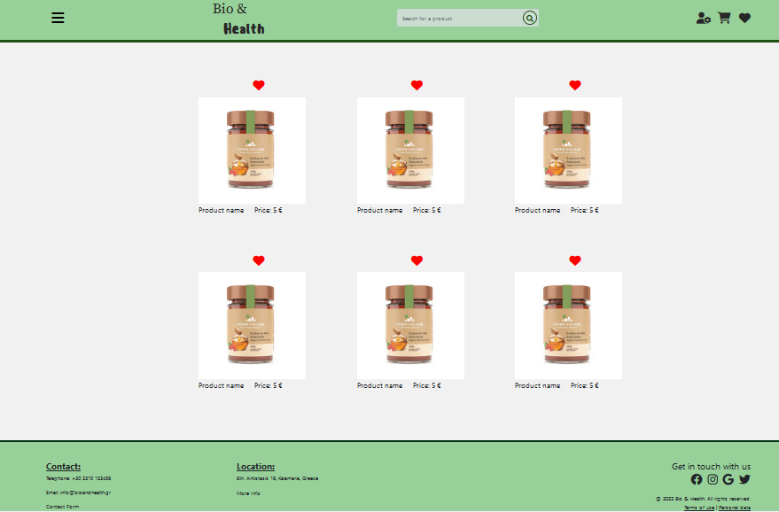

When the user clicks on the picture of a products, then the page containing detailed information about the program appears, as it is described in the UserProductInfo section of this report.

## UserMoreInfo.html

## UserOrderCompletion.html

## UserProductInfo.html

The product information page contains detailed information about a product. Τhe information contains the product’s picture on the left side and other useful information about the product on the right side. For every product, the information depicted contains elements like the product’s name, the weight, and the price of the product, together with the description of the product.

The user can click the cart picture to add the product to the cart or the heart picture to add the product to the favorites or to remove it from the favorites list. The layout of the page was developed using the Bootstrap library.

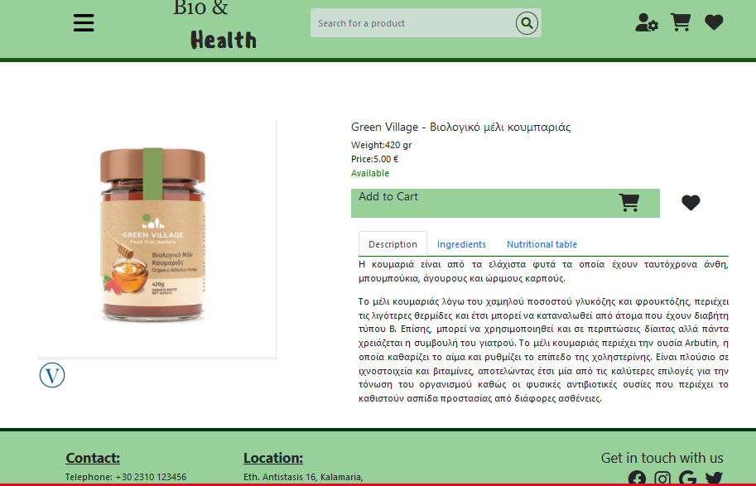

## UserSearch.html

## UserSignIn.html

This page is where the users sign in. They type their credentials in the given form and submit it. They can also sign in using one of their social media accounts and they can go to the sign-up page by clicking the “Sign Up” button.

For the layout of both the Sign Up and Sign In pages, we used the Bootstrap grid, and flexbox.

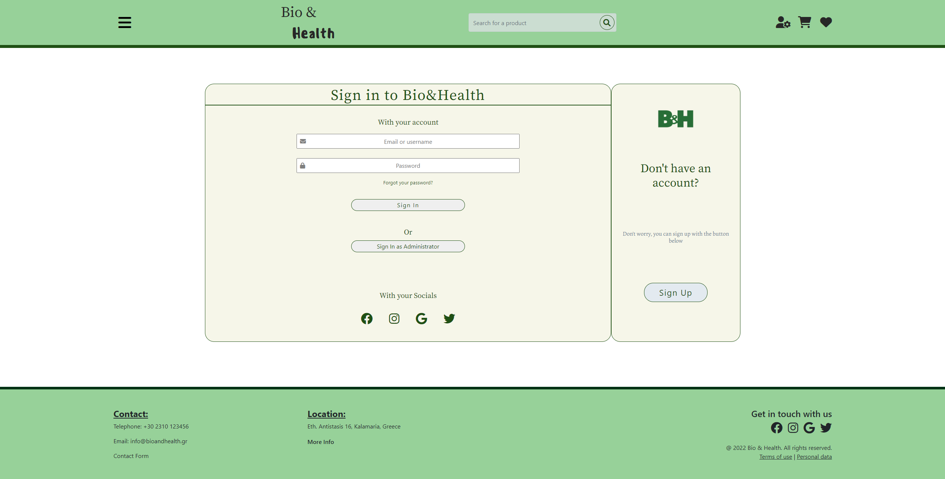

## UserSignUp.html

This is where the user creates their account. It contains a form in which the users give their account credentials (email, username, and password) and submit it. There is also the option of creating an account using one of their social media accounts.

The users also have the option to go to the sign in page if they already have an account by clicking the “Sign In” button located in the right of the page.

